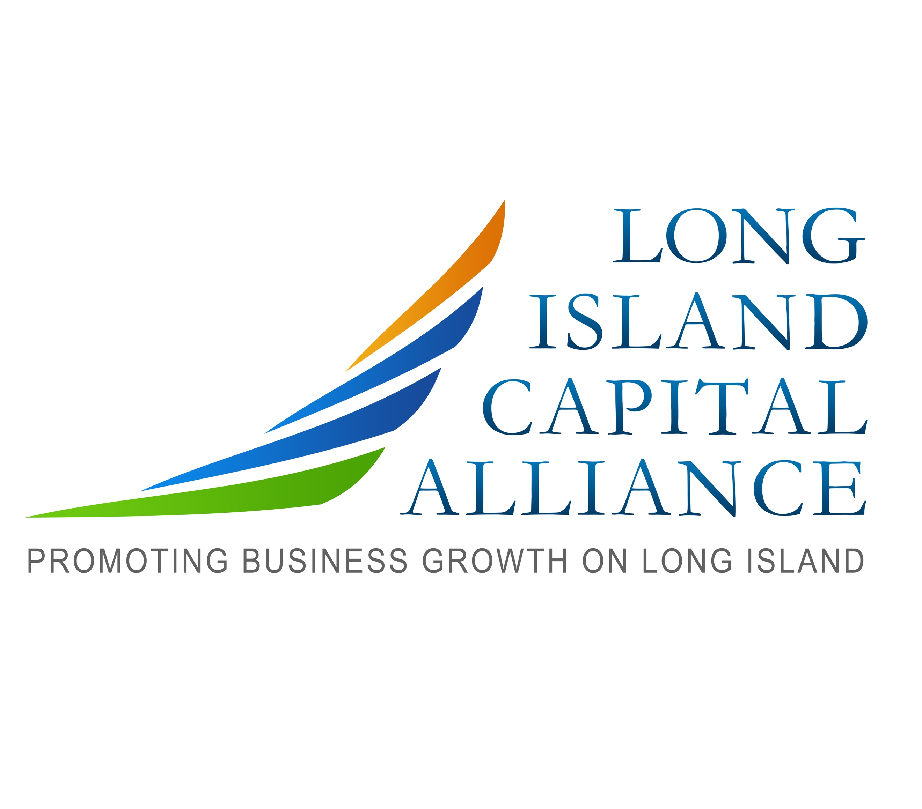
Long Island Capital Alliance
Capital Forum Call for Presenters Application
Forum Name ___________________________
Company Name_______________________________ Headquarters Location______________________________
Date Established ____________ Contact Information (name, email &phone) _______________________________

- CORPORATE OVERVIEW: Tell us 3 differentiators; compelling reasons why an investor would offer you capital?

- MANAGEMENT TEAM (i.e. CEO, CFO, CTO, Advisory Board)

- PRODUCTS/SERVICES : Description of Functions and Uses/Selling Strategy

- THE MARKET: Market Size, What is the opportunity?

- FINANCIAL INFORMATION: Current Sales, Income, Cash Flow (If Applicable) Projected (3 years) Income

- FINANCING REQUIREMENTS AND USE OF PROCEEDS: Have you pitched other events? How much money was raised?

